Chapter 8, Problem 47.

Find the output voltage v_{o}(t) in the circuit of Fig. 8.94.

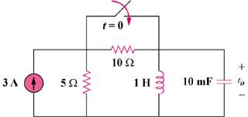

Figure 8.94
For Prob. 8.47.

